Principles of Controller Design

By Dr. L.Umanand, CEDT, IISc, Bangalore-560 012

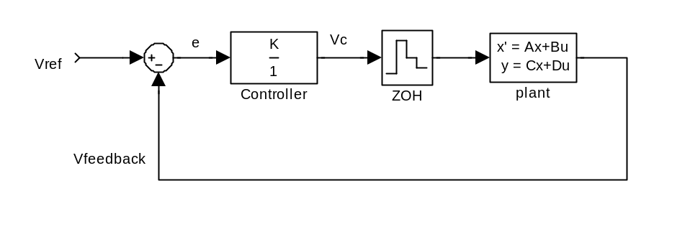
Fig.1 Function of controller K

In figure 1, K is the controller gain. The core function of this controller, K is to ensure that the error,e is always zero. By always, I mean both during steady state conditions and during transient conditions. The controller, K generates a signal V_{c} such that error, e is always kept at 0.

At what value of K is e always 0?
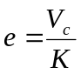 …(1)
from eqn.(1) above it is evident that e is always 0 when
- V_{c} is always zero or
- K is always
Conditions (a) above is not acceptable as in that case, one looses control of the plant and the plant operates in open loop condition. Condition (b) is the acceptable condition. So if K is made , then V_{c} is adjusted in such a manner that error, e is always 0 under all conditions of disturbances and plant parameter variations.

Control band
From eqn.(1), it is follows, that
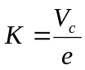 …(2)
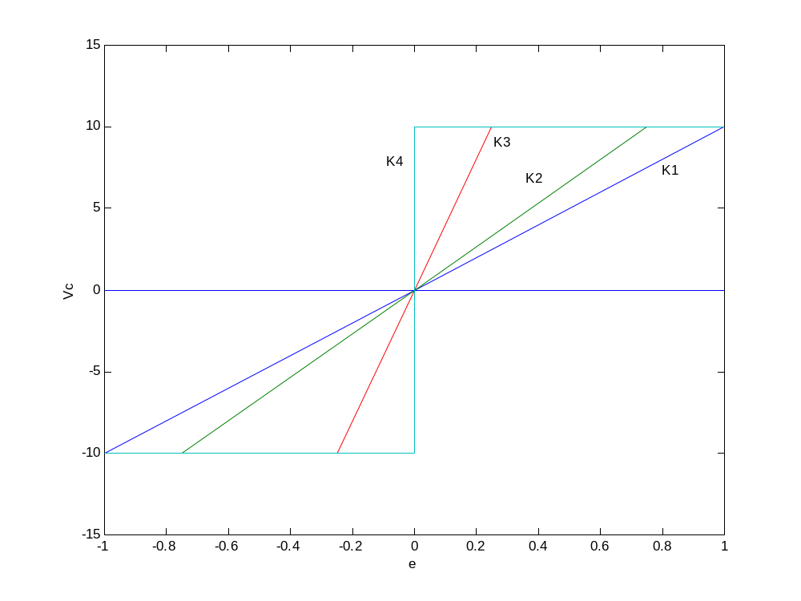
Fig.2 The control band

In all practical systems, the control signal for the plant is obtained either from a digital circuit or from an analog circuit. The digital circuits operate mainly on TTL voltage level of 5V and the analog circuits operate at +/-15V. This means there is a limit on Vc. What does this imply?
Refering to figure 2, consider that Vc can swing only between –10V and +10V. The gains K1 < K2< K3< K4. At K4 the controller gain is infinite. At K1, the gain is 10. When the gain is K1, the error, e could swing between –1 and 1. If the error goes beyond +/-1, then the Vc will saturate to +/-10. This range of error values where Vc does not saturate is called the control band. At higher gains like K2, the control band decreases to +/-0.75. So we see that as the gain increases, the control band reduces. Evidently, at K = , the control band is 0. This means that if there is even a finite error due to disturbance or parameter changes, the control signal, Vc will saturate. If Vc saturates, then the loop is broken and behaves like open loop due to loss of control on plant. The error would swing +ve when Vc goes to +ve saturation. This will lead to –ve error, when Vc will swing to –ve saturation and so on. This phenomenon is called limit cycle oscillation. This occurs due to practical limitations on the value of Vc. If Vc is capable of taking on values from - to + then, we could have achieve ideally zero error condition always.

